Creating a CSV file in Python
Introduction:
- Help Python users learn to create a csv file.
- Instructions can be done at any time before starting your code.
- Users will be able to use csv to analyze data.
Requirements:
- Computer device (PC or Laptop)
- Anaconda Server installed
- Pycharm Browser
- Python 3.0 program installed
- Data
Note: It is recommended for your device to have a minimum i7 processor.
Users:
- Engineering students enrolled in ENGR-102-216
- New learners to Python Programmers.
- Computer Engineering
Purpose:
- Provide a template/fundamental of how to properly create a csv file.
- Inform users of creating “for loops” to analyze encrypted data in Python.
- Reduce time and stress while creating a csv file.
Method:
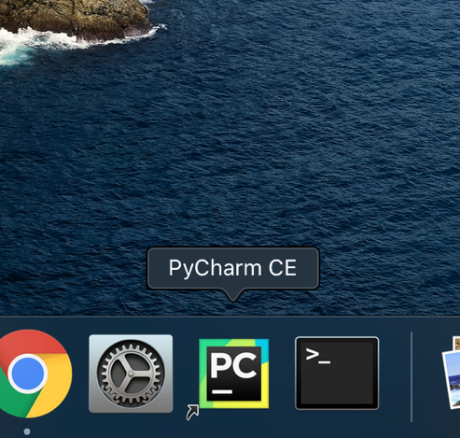 | - Click on Pycharm to open the App.
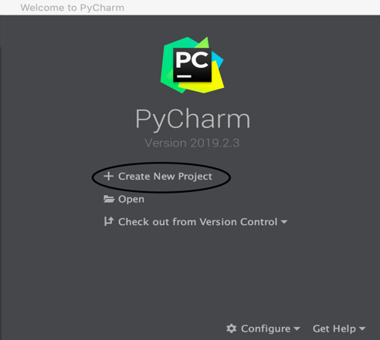 | - Click create a new project.
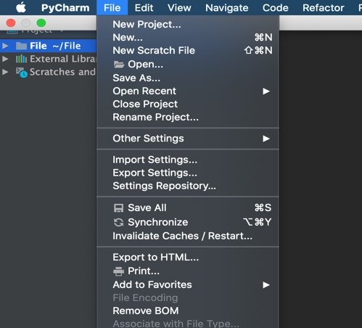 | - Create a new project in python, then go to file and click create a new text file.
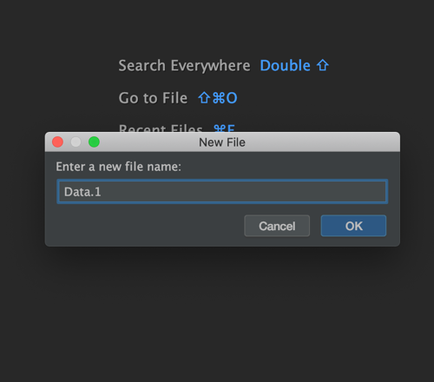 | - Type in the name for your file, ex (Data.1).
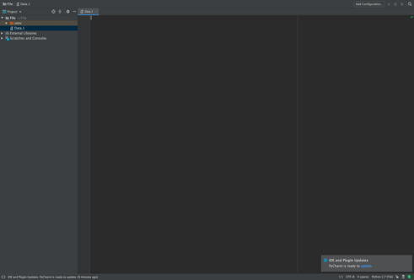 | - Click Enter
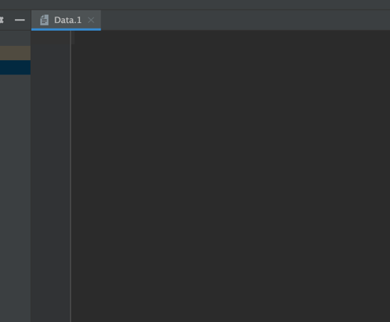 | - Click on the first line.
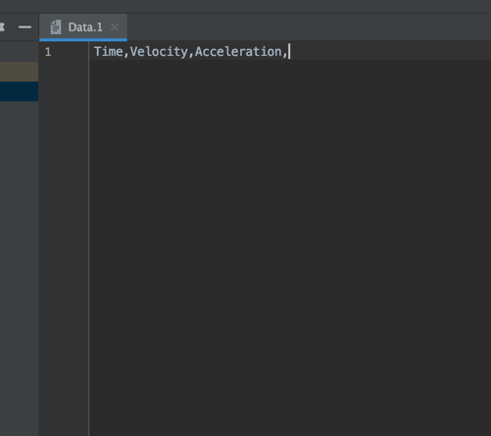 | - Type the design of your header sections and separate it by a comma, ex. (Time, Velocity, Acceleration,) on the first line.
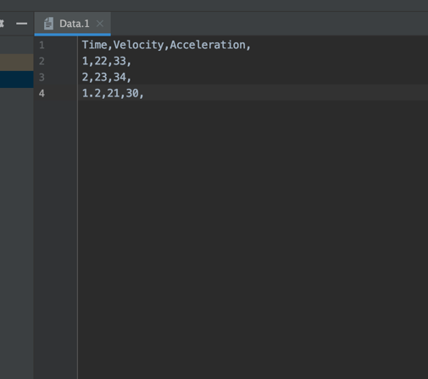 | - Type out the second and rest of the lines with your data, ex (1.2, 5, 4.16,)
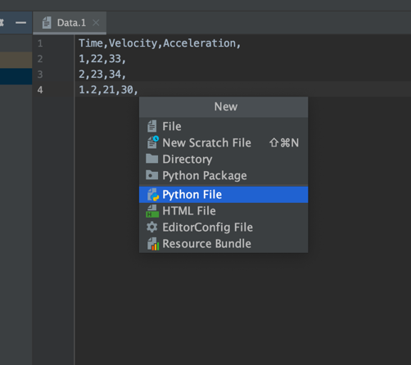 | - Create a new python file for reading the csv document after completing your csv file.
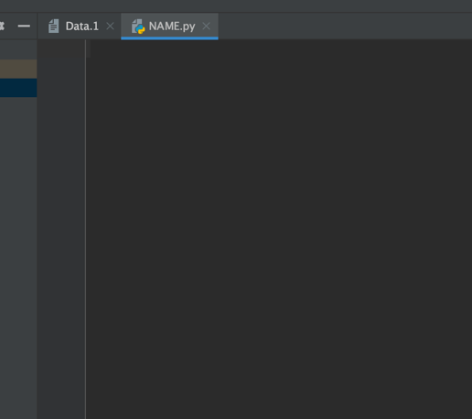 | - Click on the first line.
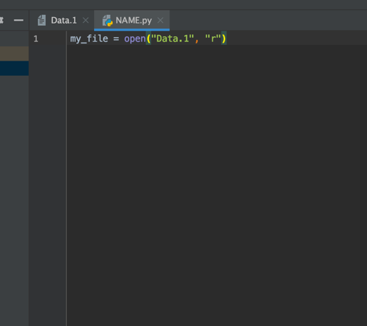 | - Open the file by typing the code “my_file = open("Data.1", "r")”
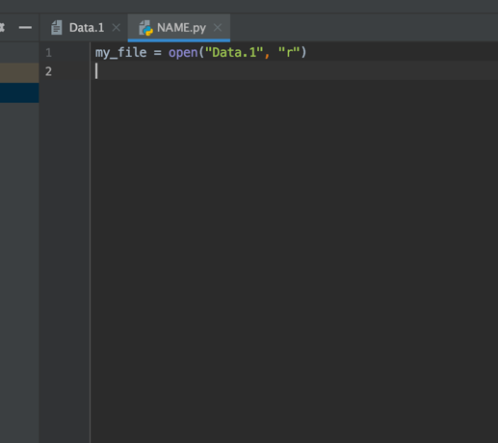 | - Click enter for a new line
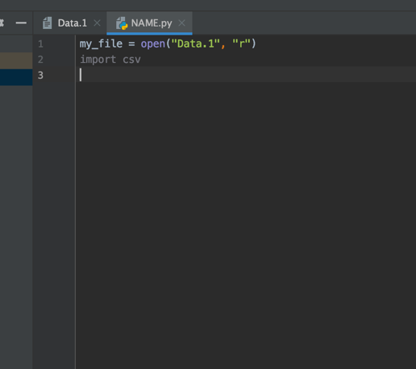 | - Type the code “import csv”, then click enter.
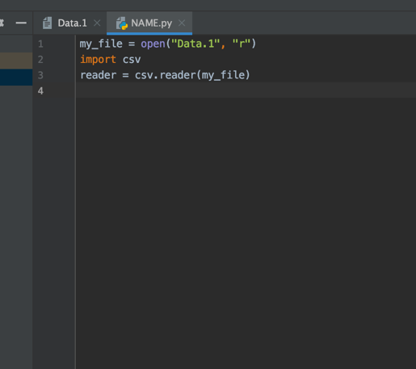 | - Type the reader command “reader = cvs.reader(my_file)”.
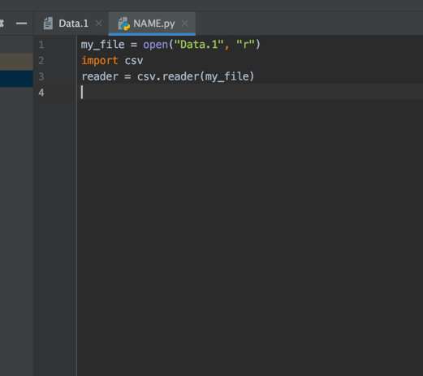 | - Press enter.
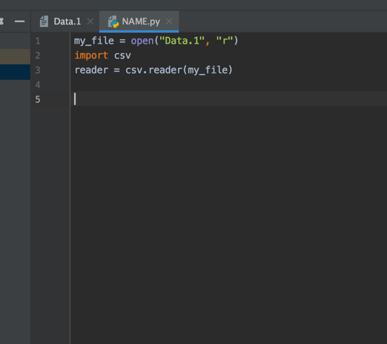 | - Click enter again.
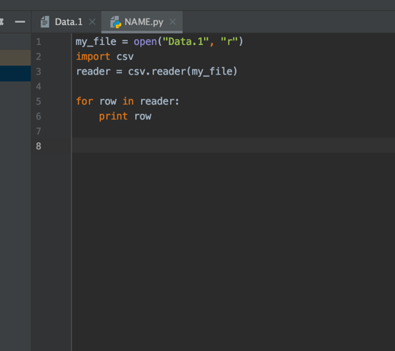 | - Create a loop to read each line by typing “for row in reader:”
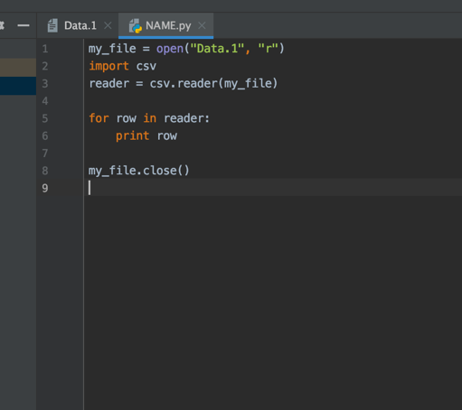 | - Close the file by stating the following code: my_file.close().

Your console should now be able to read the csv data from your document
Definitions:
- csv: this stands for Comma Separated Value. These files will be most similar to the ones you work on Excel, only difference that instead of having your data separated by cells, you will have them separated by commas.
- Pycharm: is an IDE(Integrated Development Environment) by Jetbrains. It is used for development in Python and frameworks.
- Module: A Python file with built- in functions for working with a specific task (Math, Statistics, Graphing, etc.)
- Variable: A memory location for storage values, such as x = 5, or zero = 0, etc.
- Console: The output of your input code. This section will be often show at the bottom of your Laptop Monitor.
Warnings
- Make sure you separate your values on csv by a comma, not a space or a period.
- Copy and paste each module, the program will not run if your variables or modules are not the same.
- Use a for loop rather than while loops to prevent infinite loops.
- If the program doesn’t run, debug it line by line.
Prior Knowledge:
- Python Programing
- Mathematics; Calculus, Physics, Algebra
Prior Skills:
- Creation of loops in Python
Conclusion:
You have now properly created a csv file document in Python. This was possible by creating a for loop able to reach each line and identify its variables values and characters. You are now one step closer to becoming a python programmer, congratulations. This is just the basic fundamentals of how to open and read a csv, however; you can also modify this csv file to your own preferences. This will help you analyze documents such as Excel in Python for future calculations

